
Introduction
This project focuses on analysing hospital patient data using Microsoft Excel and Microsoft Power BI. The data was cleaned, analysed, and transformed into meaningful insights to support better decision-making
Excel: Excel was used for data cleaning, preprocessing, creating calculated fields, and performing basic data analysis using formulas and Pivot Tables.
Power BI: Power BI was used to build an interactive dashboard with KPI cards, charts, and slicers to visualise hospital patient data and generate meaningful insights.
Project Objective
The objective of this project is to clean, analyse, and visualise hospital patient data using Microsoft Excel and Power BI. The project aims to create an interactive dashboard that provides meaningful insights into patient details, treatment costs, satisfaction scores, and patient outcomes, supporting better data-driven decision-making.
Dataset Description
The dataset contains hospital patient records, including patient details, medical conditions, treatment costs, length of stay, satisfaction scores, and patient outcomes. This data is used to analyse hospital performance and generate meaningful insights.
Tools Used
Microsoft Excel
Microsoft Excel was used for data cleaning, preprocessing, creating calculated fields, and performing basic data analysis.
Microsoft Power BI
Microsoft Power BI was used to build an interactive dashboard with charts, KPI cards, and slicers for effective data visualisation.
Data Preprocessing Using Excel
The dataset was cleaned by removing duplicate records, checking for missing values, and verifying data formats. Sorting, filtering, calculated fields, and Pivot Tables were also created to prepare the data for analysis.
Excel Functions Used
The following Excel functions and features were used during the project to clean, organise, and analyse the dataset:
- COUNT () – Used to count the total number of numeric values in the dataset.
- COUNTIF () – Used to count records that satisfy a specific condition.
- AVERAGE () – Used to calculate the average value of selected numerical data.
- Cost Per Day Formula – Calculated by dividing the treatment cost by the length of stay to determine the daily treatment cost.
- Sorting is used to arrange the data in ascending or descending order for better analysis.
- Filtering – Applied to display only the required records based on specific conditions.
- Pivot Table – used to summarise and analyse large amounts of data quickly and efficiently.
Power BI Dashboard
The cleaned hospital dataset was imported into Microsoft Power BI Desktop to create an interactive dashboard. The dashboard was designed to present important healthcare information in a clear and user-friendly manner. It includes KPI cards, charts, and slicers that summarise patient data and treatment details. The interactive features allow users to filter the data and analyse different aspects of hospital performance. This dashboard helps convert raw data into meaningful and easy-to-understand insights.
Dashboard Visualization
The dashboard contains different visualisations such as KPI cards, bar charts, pie charts, column charts, line charts, and slicers to represent the hospital data effectively. These visuals help compare treatment costs, analyse patient distribution, monitor satisfaction scores, and understand patient outcomes. The interactive dashboard enables users to explore the data from different perspectives, making analysis simple, clear, and informative.

Hospital Patient Analytics Dashboard 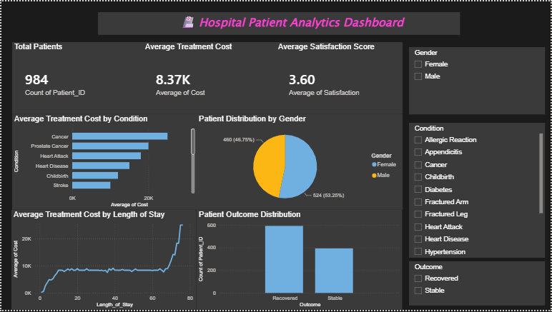

Key Insights
- The dashboard provides a clear summary of hospital patient data.
- Treatment costs vary across different medical conditions.
- Patient outcomes and satisfaction scores can be analysed effectively.
- Interactive filters help users explore the data from different perspectives.
References
Original Dataset Link:
https://www.kaggle.com/datasets/blueblushed/hospital-dataset-for-practice?resource=download
Cleaned Excel File Link:
https://docs.google.com/spreadsheets/d/1bBLwLkr4W6lXAM1T--O7B88-tsGfOQYo/edit?usp=sharing&ouid=102409279949976949270&rtpof=true&sd=true
Power BI Dashboard PDF Link:
Hospital Patient Analytics Dashboard.pdf.docx

Conclusion
This project demonstrates how Microsoft Excel and Microsoft Power BI can be used effectively to analyse hospital patient data. Excel was used to clean, organise, and prepare the dataset, while Power BI was used to create an interactive dashboard for data visualisation. The dashboard provides meaningful insights into patient details, treatment costs, satisfaction scores, and patient outcomes. Overall, this project improved my understanding of data preprocessing, analysis, and dashboard development using business intelligence tools.

